CREATIVE EDUCATIONAL SERVICES
END OF TERM I EXAMINATIONS
2024

NUMBERS

NAME: ____________________________________________ Baby CLASS

1. Count these numbers.
1 2 3 4 5 6 7 8 9 10

2. Match and write.
1 5 5 4
2 4 _______
3 1_______
4 2 _______
5 3 _______
3. Circle the correct number.
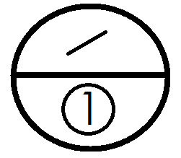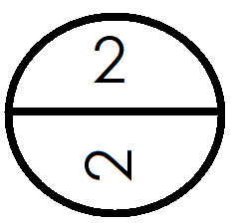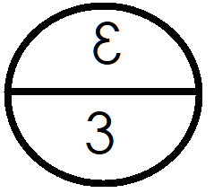

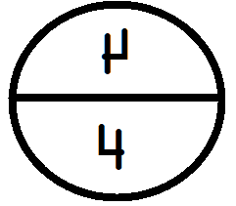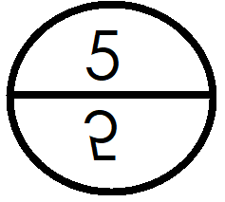
4. Circle the different number.
1 | 1 | 5
6 | 2 | 2
3 | 7 | 3
4 | 4 | 8

5. Count and match.
 4
3
1
2

6. Count and circle
1 6 5
4 2 7
5 8 3
1 4 9

7. Count and write
 =
=
=
=
=

8. Add these objects.
 + = + =
+ = + =
9. Copy and draw the shapes.

End
Good luck

